**B V2 infection with GFP M. smeg Protocol**

**Freezing media**

Materials

* BV2 media w/o purmycin & p/s
* DMSO
* 5mL serological pipet
* 50 mL serological pipet

1. Take out 45 mL of media without Puromycin & pen/strep
2. Add 5ml of dmso to that and make that the freezing media

**Replating BV2 cells**

**Materials (totals in parentheses)**

non-TC 24-well plate

non-TC 6-well plate

pipetman

pxpipette tips

1. Observe cells under microscope to estimate confluence
2. Aspirate media from flask and rinse with pre-warmed PBS (15 mL for T175)
3. Aspirate PBS and add 10 mL of pre-warmed Trypsin
4. Incubate at 37C for 15 minutes, tap to dislodge cells, and look under microscope to estimate detachment
5. Transfer trypsin to 50 mL conical and quench with 20 mLs of BV2 media without Abx
6. Count cells using Countess
7. Aliquot cells for replating into 6 and 12 well plates and spin at 400 xg for 5 min at r.t. (15 million cells for 15 wells of each genotype in 6 well plate, 5e5 cells for 12 well plate)
8. Resuspend cells in BV2 media without Abx to 8.5e5 cells/mL for 6-well plates and dilute to 1e5 cells/mL for 24-well plate
9. Plate at 8.5e5 cells/well in non-TC 6-well plate with BV2 media (1mL/well)
10. Plate at 2.5e4 cells/well in non-TC 24 well plate (250uL/well)
11. Rest plates overnight at 37C and 5% CO2

**Spinfection**

Totals in parentheses

Materials for spinfection

1. 4 15 mL conical tubes per strain of M. smeg (4 tubes)
2. 30 mL PBS per strain (30 mL)
3. 1 5 mL syringe and 1 27.5 G needle per strain (1 syringe; 1 needles)
4. Plastic cuvette with 500 uL 10% formalin (1/strain) (1 cuvettes)
5. 1 mL D10 media per strain per condition (15 mL D10 - take 20 mL)
6. D10 – DMEM with 10% FBS

Spinfection Protocol

1. Check culture OD (1mL; want OD between 0.6 and 0.8)
2. Transfer 10 mL of M. smeg culture to 15 mL conical
3. Pellet for 5 min at max speed
4. Decant supernatant and resuspend in 10 mL PBS
5. Repeat steps 2-3 for a total of 2 PBS washes
6. Break-up aggregates - pull 4 mL through a 27.5 G needle eject through needle into a fresh conical
   1. Decontaminate needle and syringe with bleach and dispose in the sharps container
7. Spin at 55 rcf for 5 min to pellet clumps
8. Transfer supernatant to a new conical
9. Take OD of each cell suspension
   1. Place 1 mL in cuvette, rinse cuvette with EtOH and dry before taking OD
$5e^{8}\frac{CFU}{mL}=1{OD}_{600}$

10. Prepare infection media
11. Remove culture media from plate and replace with 1 mL infection media in each well at an MOI of 10
12. Spinfect for 10 min @ 200 xg at rt
13. Aspirate supernatant and add 1 mL fresh D10
14. Incubate for 1hr and 18hr
15. Process 1 hpi samples and place remaining plates in 37 C incubator overnight

Flow Prep (To check phagocytosis)

1. Add 1 mL of trypsin to each well, incubate for 10 min at 37 C, and pipet to break up clumps.
2. Spin down and wash in 1 mL FACS buffer
3. Spin down and resuspend in 200 uL FACS buffer
4. Transfer to well plates according to diagram below

Flow Prep (to check apoptosis)

1. Add 1 mL of trypsin to each well, incubate for 10 min at 37 C, and pipet to break up clumps.
2. Spin down and wash in 1 mL FACS buffer
3. Spin down and resuspend in 200 uL FACS buffer
4. Transfer to well plates according to diagram below

250ul x 20wells= 5mL

**** Make sure to add pre-autoclaved glass coverslips to 24 well plates.

**BV2s experiment Layout**

For naive

18 hpi

1 hpi

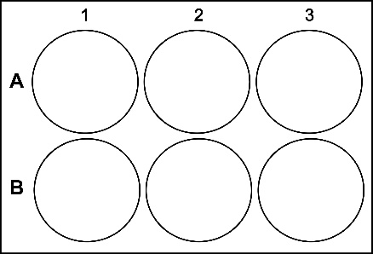 

D D D

D D D

C C C

C C C

For apoptosis and phagocyttosis by flow

1hpi 1hpi



D D D

C C C

C C C

D D D

For apoptosis by flow LATE

18 hpi



C C C

D D D

For phagocytosis/actin by microscopy

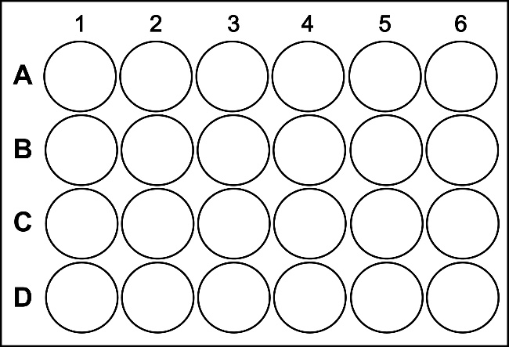

18 hpi

1 hpi

D D D

D D D

C C C

C C C